Python is a general-purpose interpreted, object-oriented, and high-level programming language It was created by Guido van Rossum during 1985- 1990 and released in 1991
It is used for:
- web development (server-side)
- software development
- mathematics
- System scripting
- Data Analysis
- IoT (Hardware)
History of Python
Python was developed by Guido van Rossum in the late eighties and early nineties at the National Research Institute for Mathematics and Computer Science in the Netherlands.
Python is derived from many other languages, including ABC, Modula-3, C, C++, Algol-68, SmallTalk, and Unix shell and other scripting languages.
Python is now maintained by a core development team at the institute, although Guido van Rossum still holds a vital role in directing its progress.
What can Python do?
- Python can be used on a server to create web applications.
- Python can be used alongside software to create workflows.
- Python can connect to database systems. It can also read and modify files.
- Python can be used to handle big data and perform complex mathematics.
Why Python?
- Python works on different platforms (Windows, Mac, Linux, Raspberry Pi, etc).
- Python has a simple syntax similar to the English language.
- Python has syntax that allows developers to write programs with fewer lines than some other programming languages.
- Python runs on an interpreter system, meaning that code can be executed as soon as it is written.
- Python can be treated in a procedural way, an object-orientated way or a functional way.
Python Installation

Windows Installation
Here are the steps to install Python on Windows machine.
- Open a Web browser and go to https://www.python.org/downloads/.
- Follow the link for the Windows installer python-XYZ.msi file where XYZ is the version you need to install.
- To use this installer python-XYZ.msi, the Windows system must support Microsoft Installer 2.0. Save the installer file to your local machine and then run it to find out if your machine supports MSI.
- Run the downloaded file. This brings up the Python install wizard, which is really easy to use. Just accept the default settings, wait until the install is finished, and you are done.

Python IDE
Python in an Integrated Development Environment, such as Thonny, Pycharm, Netbeans, Jupyter Notebook or Eclipse which are particularly useful when managing larger collections of Python files.
Python Syntax compared to other programming languages
- Python was designed for readability, and has some similarities to the English language with influence from mathematics.
- Python uses new lines to complete a command, as opposed to other programming languages which often use semicolons or parentheses.
- Python relies on indentation, using whitespace, to define scope; such as the scope of loops, functions and classes. Other programming languages often use curly-brackets for this purpose.

Creating a Comment
Comments starts with a #, and Python will ignore them:

Example
#This is a comment
Comments can be placed at the end of a line, and Python will ignore the rest of the line:

Example
print("Hello, World!") #This is a comment
Since Python will ignore string literals that are not assigned to a variable, you can add a multiline string (triple quotes) in your code, and place you comment inside it:

Example
"""
This is a comment
written in
more than just one line
"""

Creating Variables
Variables are containers for storing data values.
Unlike other programming languages, Python has no command for declaring a variable.
A variable is created the moment you first assign a value to it.
Variable Names
A variable can have a short name (like x and y) or a more descriptive name (age, carname, total_volume). Rules for Python variables:
- A variable name must start with a letter or the underscore character
- A variable name cannot start with a number
- A variable name can only contain alpha-numeric characters and underscores A-z, 0-9, and _
- Variable names are case-sensitive (age, Age and AGE are three different variables)

Example
x = 5
y = "John"
print(x)
print(y)
Variables do not need to be declared with any particular type and can even change type after they have been set.

Example
x = 4# x is of type int
x = "Sally"# x is now of type str
print(x)
Assign Value to Multiple Variables
Python allows you to assign values to multiple variables in one line:
Example
x, y, z = "Orange", "Banana", "Cherry"
print(x)
print(y)
print(z)
And you can assign the same value to multiple variables in one line:
Example
x = y = z = "Orange"
print(x)
print(y)
print(z)
Output Variables
The Python print statement is often used to output variables.
To combine both text and a variable, Python uses the + character:
Example
x = "awesome"
print("Python is " + x)
You can also use the + character to add a variable to another variable:
Example
x = "Python is "
y = "awesome"
z = x + y
print(z)
If you try to combine a string and a number, Python will give you an error:
Example
x = 5
y = "John"
print(x + y)
Python Numbers
There are three numeric types in Python:
- int
- float
- complex
Variables of numeric types are created when you assign a value to them:
Example
x = 1 # int
y = 2.8 # float
z = 1j # complex 1 is real and j is imaginary
To verify the type of any object in Python, use the type() function:
Example
print(type(x))
print(type(y))
print(type(z))
Type Conversion
You can convert from one type to another with the int(), float(), and complex() methods:

Example
Convert from one type to another:
x = 1# int
y = 2.8# float
z = 1j # complex
#convert from int to float:
a = float(x)
#convert from float to int:
b = int(y)
#convert from int to complex:
c = complex(x)
print(a)
print(b)
print(c)
print(type(a))
print(type(b))
print(type(c))

Assign String to a Variable
Assigning a string to a variable is done with the variable name followed by an equal sign and the string:
Example
a = "Hello"
print(a)
Multiline Strings
You can assign a multiline string to a variable by using three quotes:
Example
You can use three double quotes:
a = """Loremipsum dolor sit amet,
consecteturadipiscingelit,
sed do eiusmodtemporincididunt
utlabore et dolore magna aliqua."""
print(a)
Or three single quotes:
Strings
Slicing
You can return a range of characters by using the slice syntax.
Specify the start index and the end index, separated by a colon, to return a part of the string.
Example
Get the characters from position 2 to position 5 (not included):
b = "Hello, World!"
print(b[2:5])
Output llo
Get the characters from position 5 to position 1, starting the count from the end of the string:
b = "Hello, World!"
print(b[-6:-1])
output world
To get the length of a string, use the len() function.
Example
The len() function returns the length of a string:
a = "Hello, World!"
print(len(a))
The strip() method removes any whitespace from the beginning or the end:
a = " Hello, World! "
print(a.strip()) # returns "Hello, World!"
The lower() method returns the string in lower case:
a = "Hello, World!"
print(a.lower())
The upper() method returns the string in upper case:
a = "Hello, World!"
print(a.upper())
The replace() method replaces a string with another string:
a = "Hello, World!"
print(a.replace("H", "J"))
Check if the phrase "ain" is present in the following text:
txt = "The rain in Spain stays mainly in the plain"
x = "ain" in txt
print(x)
Output True
To concatenate, or combine, two strings you can use the + operator.
Example
Merge variable a with variable b into variable c:
a = "Hello"
b = "World"
c = a + b
print(c)
To add a space between them, add a " ":
a = "Hello"
b = "World"
c = a + " " + b
print(c)
Python Operators
Operators are used to perform operations on variables and values.
Python divides the operators in the following groups:
- Arithmetic operators
- Assignment operators
- Comparison operators
- Logical operators
- Identity operators
- Membership operators
Python Assignment Operators
Assignment operators are used to assign values to variables:

Operator | Name | Example
+ | Addition | x + y
- | Subtraction | x - y
* | Multiplication | x * y
/ | Division | x / y
% | Modulus | x % y

Operator | Example | Same As
= | x = 5 | x = 5
+= | x += 3 | x = x + 3
-= | x -= 3 | x = x - 3
*= | x *= 3 | x = x * 3
/= | x /= 3 | x = x / 3
%= | x %= 3 | x = x % 3

Python Comparison Operators
Comparison operators are used to compare two values:

Operator | Name | Example
== | Equal | x == y
!= | Not equal | x != y
> | Greater than | x > y
< | Less than | x < y
>= | Greater than or equal to | x >= y
<= | Less than or equal to | x <= y
Python Logical Operators
Logical operators are used to combine conditional statements:

And, or, not

Python Identity Operators
Identity operators are used to compare the objects, not if they are equal, but if they are actually the same object, with the same memory location:

Operator | Description | Example
is | Returns true if both variables are the same object | x is y
is not | Returns true if both variables are not the same object | x is not y
Python Membership Operators
Membership operators are used to test if a sequence is presented in an object:
In, not in
Examples:
x = ["apple", "banana"]
print("banana" in x)
output: True

x = ["apple", "banana"]
print("pineapple" not in x)
output: False

Python Conditions and If statements
Python supports the usual logical conditions from mathematics:
Equals: a == b
Not Equals: a != b
Less than: a < b
Less than or equal to: a <= b
Greater than: a > b
Greater than or equal to: a >= b
These conditions can be used in several ways, most commonly in "if statements" and loops.
An "if statement" is written by using the if keyword.
Example
If statement:
a = 33
b = 200
if b > a:
print("b is greater than a")
If Else

Example
a = 200
b = 33
if b > a:
print("b is greater than a")
else:
print("b is not greater than a")

Elif
The elif keyword is pythons way of saying "if the previous conditions were not true, then try this condition".
Example
a = 33
b = 33
if b > a:
print("b is greater than a")
elif a == b:
print("a and b are equal")
Else
The else keyword catches anything which isn't caught by the preceding conditions.
Example
a = 200
b = 33
if b > a:
print("b is greater than a")
elif a == b:
print("a and b are equal")
else:
print("a is greater than b")
Short Hand If
If you have only one statement to execute, you can put it on the same line as the if statement.
Example
One line if statement:
if a > b: print("a is greater than b")
Short Hand If ... Else
If you have only one statement to execute, one for if, and one for else, you can put it all on the same line:
Example
One line if else statement:
a = 2
b = 330
print("A") if a > b else print("B")
You can also have multiple else statements on the same line:
Example
One line if else statement, with 3 conditions:
a = 330
b = 330
print("A") if a > b else print("=") if a == b else print("B")
And
The and keyword is a logical operator, and is used to combine conditional statements:
Example
Test if a is greater than b, AND if c is greater than a:
a = 200
b = 33
c = 500
if a > b and c > a:
print("Both conditions are True")
Or
The or keyword is a logical operator, and is used to combine conditional statements:
Example
Test if a is greater than b, OR if a is greater than c:
a = 200
b = 33
c = 500
if a > b or a > c:
print("At least one of the conditions is True")

Nested If
You can have if statements inside if statements, this is called nested if statements.
Example
x = 41
if x > 10:
print("Above ten,")
if x > 20:
print("and also above 20!")
else:
print("but not above 20.")
Python Loops
Python has two primitive loop commands:
- for loops
- while loops

Python For Loops
A for loop is used for iterating over a sequence (that is either a list, a tuple, a dictionary, a set, or a string).

Examples

Print each fruit in a fruit list:
fruits = ["apple", "banana", "cherry"]
for x in fruits:
print(x)

Loop through the letters in the word "banana":
for x in "banana":
print(x)
Exit the loop when x is "banana":
fruits = ["apple", "banana", "cherry"]
for x in fruits:
print(x)
if x == "banana":
break
Exit the loop when x is "banana", but this time the break comes before the print:
fruits = ["apple", "banana", "cherry"]
for x in fruits:
if x == "banana":
break
print(x)
Do not print banana:
fruits = ["apple", "banana", "cherry"]
for x in fruits:
if x == "banana":
continue
print(x)

The range() Function
To loop through a set of code a specified number of times, we can use the range() function,
The range() function returns a sequence of numbers, starting from 0 by default, and increments by 1 (by default), and ends at a specified number.
Example
Using the range() function:
for x in range(6):
print(x)
Note that range(6) is not the values of 0 to 6, but the values 0 to 5.
The range() function defaults to 0 as a starting value, however it is possible to specify the starting value by adding a parameter: range(2, 6), which means values from 2 to 6 (but not including 6):
Example
Using the start parameter:
for x in range(2, 6):
print(x)
The range() function defaults to increment the sequence by 1, however it is possible to specify the increment value by adding a third parameter: range(2, 30, 3):
Example
Increment the sequence with 3 (default is 1):
for x in range(2, 30, 3):
print(x)

Nested Loops
A nested loop is a loop inside a loop.
The "inner loop" will be executed one time for each iteration of the "outer loop":
Example
Print each adjective for every fruit:
a = ["red", "big", "tasty"]
b = ["apple", "banana", "cherry"]
for x in a:
for y in b:
print(x, y)

The while Loop
With the while loop we can execute a set of statements as long as a condition is true.
Example
Print i as long as i is less than 6:
i = 1
while i< 6:
print(i)
i += 1

The break Statement
With the break statement we can stop the loop even if the while condition is true:
Example
Exit the loop when i is 3:
i = 1
while i< 6:
print(i)
if i == 3:
break
i += 1
The continue Statement
With the continue statement we can stop the current iteration, and continue with the next:
Example
Continue to the next iteration if i is 3:
i = 0
while i< 6:
i += 1
if i == 3:
continue
print(i)

Python Functions
A function is a block of code which only runs when it is called.
You can pass data, known as parameters, into a function.
A function can return data as a result.

Creating a Function
In Python a function is defined using the def keyword:
defmy_function():
print("Hello from a function")

Calling a Function
To call a function, use the function name followed by parenthesis:
Example
defmy_function():
print("Hello from a function")
my_function()
Parameters
Information can be passed to functions as parameter.
Parameters are specified after the function name, inside the parentheses. You can add as many parameters as you want, just separate them with a comma.
The following example has a function with one parameter (fname). When the function is called, we pass along a first name, which is used inside the function to print the full name:

defmy_function(fname):
print("Welcome " +fname)
my_function("Jawaid")
my_function("Owais")
my_function("Assad")

Default Parameter Value
The following example shows how to use a default parameter value.
If we call the function without parameter, it uses the default value:

defmy_function(country = "Pakistan"):
print("I am from " + country)
my_function("Sweden")
my_function("India")
my_function()
my_function("Brazil")

defPlus(a,b):
t=a+b
print(t)
Plus(5,6)

Use return keyword
defCalc(a,b):
return a*b
print(Calc(5,6))

Passing a List as a Parameter
You can send any data types of parameter to a function (string, number, list, dictionary etc.), and it will be treated as the same data type inside the function.
E.g. if you send a List as a parameter, it will still be a List when it reaches the function:

Def fun1(food):
for x in food:
print(x)
arr=["Briyani","Korma","Salad"]
fun1(arr)

Default Argument
def info( name, age = 35 ):
"This prints a passed info into this function"
print("Name: ", name)
print("Age ", age)

info( age=50, name="Jawaid" )
info( name="Jawaid" )

Python Collections (Arrays)
There are four collection data types in the Python programming language:
List is a collection which is ordered and changeable. Allows duplicate members.
Tuple is a collection which is ordered and unchangeable. Allows duplicate members.
Set is a collection which is unordered and unindexed. No duplicate members.
Dictionary is a collection which is unordered, changeable and indexed. No duplicate members.

List
A list is a collection which is ordered and changeable. In Python lists are written with square brackets.

Example
Create a List:
t = ["apple", "banana", "cherry"]
print(t)
Using the list() constructor to make a List:
thislist = list(("apple", "banana", "cherry")) # note the double round-brackets
print(thislist)
ml=[1,2,3,"Jawaid",[1.5,935.6]]
print(ml)

for a in ml:
print(a)
Print the second item of the list:
thislist = ["apple", "banana", "cherry"]
print(thislist[1])
Return the third, fourth, and fifth item:
thislist = ["apple", "banana", "cherry", "orange", "kiwi", "melon", "mango"]
print(thislist[2:5])

Change the second item:
thislist = ["apple", "banana", "cherry"]
thislist[1] = "blackcurrant"
print(thislist)

Print all items in the list, one by one:
thislist = ["apple", "banana", "cherry"]
for x in thislist:
print(x)
Check if "apple" is present in the list:
thislist = ["apple", "banana", "cherry"]
if "apple" in thislist:
print("Yes, 'apple' is in the fruits list")
Print the number of items in the list:
thislist = ["apple", "banana", "cherry"]
print(len(thislist))

Using the append() method to append(add) an item:
thislist = ["apple", "banana", "cherry"]
thislist.append("orange")
print(thislist)

To add an item at the specified index, use the insert() method:

Example
Insert an item as the second position:
thislist = ["apple", "banana", "cherry"]
thislist.insert(1, "orange")
print(thislist)
The remove() method removes the specified item:
thislist = ["apple", "banana", "cherry"]
thislist.remove("banana")
print(thislist)
The pop() method removes the last item if index is not specified:
thislist = ["apple", "banana", "cherry"]
thislist.pop(1)
print(thislist)
thislist.pop()
print(thislist)

The del keyword removes the specified index:
thislist = ["apple", "banana", "cherry"]
del thislist[0]
print(thislist)
The del keyword can also delete the list completely:
thislist = ["apple", "banana", "cherry"]
del thislist

The clear() method empties(Clear) the list:
thislist = ["apple", "banana", "cherry"]
thislist.clear()
print(thislist)
Join two list:
list1 = ["a", "b" ,"c"]
list2 = [1, 2, 3]
list3 = list1 + list2
print(list3)
Append list2 into list1:
list1 = ["a", "b" ,"c"]
list2 = [1, 2, 3]
for x in list2:
list1.append(x)
print(list1)
Use the extend() method to add list2 at the end of list1:
list1 = ["a", "b" ,"c"]
list2 = [1, 2, 3]
list1.extend(list2)
print(list1)
a=[1,2,3,4,5,6,7,8,9]
print(a)
#To find odd number from list
print("Odd NUmber",a[0:9:2])
#To find even number from list
print("Even NUmber ",a[1:9:2])
#Reverse direction
print(a[3:0:-1])

# Calulate all members of each others
s="Aptech"
print(s[2:6])
x = [1, 2,2]
y = [5, 10]
al = [a*b for a in x for b in y]
print(al)

#No duplicate data
y=[]
for i in x:
if i not in y:
y.append(i)
print(y)
#Find maximum no
def max_No( list ):
m = list[ 0 ]
for a in list:
if a > m:
m = a
return m
print(max_No([11, 2, -8, 0]))

#Find minimum no
def min_No( list ):
m = list[ 0 ]
for a in list:
if a < m:
m = a
return m
print(min_No([11,2,-8,0]))

Tuple
A tuple is a collection which is ordered and unchangeable. In Python tuples are written with round brackets.
Create a Tuple:
thistuple = ("apple", "banana", "cherry")
print(thistuple)

A tuple can also be created without using parentheses. This is known as tuple packing.
my_tuple = 3, 4.6, "dog"
print(my_tuple)

# tuple unpacking is also possible
a, b, c = my_tuple

print(a) # 3
print(b) # 4.6
print(c) # dog
my_tuple = ('p','e','r','m','i','t')

print(my_tuple[0]) # 'p'
print(my_tuple[5]) # 't'

n_tuple = ("mouse", [8, 4, 6], (1, 2, 3))

# nested index
print(n_tuple[0][3]) # 's'
print(n_tuple[1][1]) # 4
print(n_tuple[2][2]) #3

Python allows negative indexing for its sequences.
The index of -1 refers to the last item, -2 to the second last item and so on.
my_tuple = ('p','e','r','m','i','t')

# Output: 't'
print(my_tuple[-1])

# Output: 'p'
print(my_tuple[-6])

We can access a range of items in a tuple by using the slicing operator - colon ":".
my_tuple = ('p','r','o','g','r','a','m','i','z')

# elements 2nd to 4th
# Output: ('r', 'o', 'g')
print(my_tuple[1:4])

# elements beginning to 2nd
# Output: ('p', 'r')
print(my_tuple[:-7])

# elements 8th to end
# Output: ('i', 'z')
print(my_tuple[7:])

# elements beginning to end
# Output: ('p', 'r', 'o', 'g', 'r', 'a', 'm', 'i', 'z')
print(my_tuple[:])

my_tuple = ('a','p','p','l','e',)

print(my_tuple.count('p')) # Output: 2
print(my_tuple.index('l')) # Output: 3

Using a for loop we can iterate through each item in a tuple.
for name in ('Jawaid','Owais','Assad'):
print("Hello",name)
Convert the tuple into a list to be able to change it:
x = ("apple", "banana", "cherry")
y = list(x)
y[1] = "kiwi"
x = tuple(y)
print(x)
Set
A set is an unordered collection of items. Every element is unique (no duplicates) and must be immutable (which cannot be changed).

Create a Set:
thisset = {"apple", "banana", "cherry"}
print(thisset)

Loop through the set, and print the values:
thisset = {"apple", "banana", "cherry"}
for x in thisset:
print(x)
#mixed datatypes
st = {1.0, "Hello", (1, 2, 3)}
print(st)

# add an element
st.add(95)
print(st)

# add multiple elements
st.update([2,3,4])
print(st)

# add list and set
st.update([4,5], {1,6,8})
print(st)

st.discard(4)
print(st)
# remove an element
st.remove(6)
print(my_set)

names = set()
names.add("Jawaid")
names.add("Owais")
names.add("Jawaid")
print(names)

#set of unique elements
my_set = set("HelloWorld")
print(my_set)

# pop an element
# Output: H
print(my_set.pop())

# pop another element
# Output: e
my_set.pop()
print(my_set)

# clear my_set
#Output: set()
my_set.clear()
print(my_set)
Union of A and B is a set of all elements from both sets.
Union is performed using | operator. Or .union method.
# initialize A and B
A = {1, 2, 3, 4, 5}
B = {4, 5, 6, 7, 8}

# use | operator
# Output: {1, 2, 3, 4, 5, 6, 7, 8}
print(A | B)
print(A.union(B))

Intersection of A and B is a set of elements that are common in both sets.
Intersection is performed using & operator. Same can be accomplished using the method intersection()

# use & operator
# Output: {4, 5}
print(A & B)

Difference of A and B (A - B) is a set of elements that are only in A but not in B. Similarly, B - A is a set of element in B but not in A.
Difference is performed using - operator. Same can be accomplished using the method difference().

print(A - B)
A.difference(B)
B.difference(A)
Symmetric Difference of A and B is a set of elements in both A and B except those that are common in both.
Symmetric difference is performed using ^ operator. Same can be accomplished using the method symmetric_difference().
print(A ^ B)

Dictionary
A dictionary is a collection which is unordered, changeable and indexed. In Python dictionaries are written with curly brackets, and they have keys and values.
Dictionaries are optimized to retrieve values when the key is known.
Create and print a dictionary:
thisdict ={ "brand": "Ford", "model": "Mustang", "year": 1964}
print(thisdict)
# dictionary with mixed keys
my_dict = {'name': 'Jawaid', 1: [2, 4, 3]}
dct = {'name':'Jawaid', 'age': 51}

# Output: Jawaid
print(dct['name'])

# Output: 51
print(dct.get('age'))

# update value
my_dict['age'] = 27

#Output: {'age': 27, 'name': 'Jack'}
print(my_dict)

# add item
my_dict['address'] = 'Downtown'

# Output: {'address': 'Downtown', 'age': 27, 'name': 'Jack'}
print(my_dict)

# create a dictionary
squares = {1:1, 2:4, 3:9, 4:16, 5:25}

# remove a particular item
# Output: 16
print(squares.pop(4))

# Output: {1: 1, 2: 4, 3: 9, 5: 25}
print(squares)

# remove an arbitrary item
# Output: (1, 1)
print(squares.popitem())

# Output: {2: 4, 3: 9, 5: 25}
print(squares)

# delete a particular item
del squares[5]

# Output: {2: 4, 3: 9}
print(squares)

# remove all items
squares.clear()

# Output: {}
print(squares)

# delete the dictionary itself
del squares

# Throws Error
# print(squares)

Data analysis with python

Pandas
Pandas is one of the most popular Python libraries for Data Science and Analytics. Pandas is an open-source, BSD-licensed Python library providing high-performance, easy-to-use data structures and data analysis tools for the Python programming language. The name Pandas is derived from the word Panel Data – an Econometrics from Multidimensional data.
In 2008, developer Wes McKinney started developing pandas when in need of high performance, flexible tool for analysis of data.
Prior to Pandas, Python was majorly used for data munging and preparation. It had very little contribution towards data analysis. Pandas solved this problem. Using Pandas, we can accomplish five typical steps in the processing and analysis of data, regardless of the origin of data — load, prepare, manipulate, model, and analyze.
Python with Pandas is used in a wide range of fields including academic and commercial domains including finance, economics, Statistics, analytics, etc.
Key Features of Pandas
- Fast and efficient DataFrame object with default and customized indexing.
- Tools for loading data into in-memory data objects from different file formats.
- Data alignment and integrated handling of missing data.
- Reshaping and pivoting of date sets.
- Label-based slicing, indexing and subsetting of large data sets.
- Columns from a data structure can be deleted or inserted.
- Group by data for aggregation and transformations.
- High performance merging and joining of data.
- Time Series functionality.
Pandas deals with the following three data structures −
- Series
- DataFrame
- Panel
Data Structure | Dimensions | Description
Series | 1 | 1D labeled homogeneous array, sizeimmutable.
Data Frames | 2 | General 2D labeled, size-mutable tabular structure with potentially heterogeneously typed columns.
Panel | 3 | General 3D labeled, size-mutable array.

Series
Series is a one-dimensional array like structure with homogeneous data. For example, the following series is a collection of integers 10, 23, 56, …
10 | 23 | 56 | 17 | 52 | 61 | 73 | 90 | 26 | 72

Key Points
- Homogeneous data
- Size Immutable
- Values of Data Mutable

DataFrame
DataFrame is a two-dimensional array with heterogeneous data. For example,
Name | Age | Gender | Rating
Steve | 32 | Male | 3.45
Lia | 28 | Female | 4.6
Vin | 45 | Male | 3.9
Katie | 38 | Female | 2.78
The table represents the data of a sales team of an organization with their overall performance rating. The data is represented in rows and columns. Each column represents an attribute and each row represents a person.

Data Type of Columns
The data types of the four columns are as follows −
Column | Type
Name | String
Age | Integer
Gender | String
Rating | Float

Key Points
- Heterogeneous data
- Size Mutable
- Data Mutable

Panel
Panel is a three-dimensional data structure with heterogeneous data. It is hard to represent the panel in graphical representation. But a panel can be illustrated as a container of DataFrame.

Key Points
- Heterogeneous data
- Size Mutable
- Data Mutable
Pandas.Series
Example:
from pandas import Series
d1=Series(["Jawaid","Owais","Assad"])
d1
d1[1]
d1=Series(["Jawaid","Owais","Assad"],index=(1,2,3))
d1
d1=Series(["Jawaid","Owais","Assad"],index=("me","S1","S2"))
d1
#Normal Dictionary data with key and values
d2={"Jawaid":51,"Owais":25,"Assad":21}
#Convert into Series
d2s=Series(d2)
d2s
d2s["Owais"]
#Other way
import pandas as pd
s = pd.Series([1,2,3,4,5],index = ['a','b','c','d','e'])

#retrieve the first three element
print (s[:2])
print(s[-3:])
print(s[‘a’])
print s[['a','c','d']]

Data Frame
A Data frame is a two-dimensional data structure, i.e., data is aligned in a tabular fashion in rows and columns.
Features of DataFrame
Potentially columns are of different types
Size – Mutable
Labeled axes (rows and columns)
Can Perform Arithmetic operations on rows and columns
from pandas import DataFrame
Dic1={"Name":["Jawaid","Owais","Assad"],"Last Name":["Iqbal","Awan","Awan"],"Age":[51,25,20]}
df=DataFrame(Dic1)
df
#For x index
df.iloc[1]

import pandas as pd
data = [['Alex',10],['Bob',12],['Clarke',13]]
df = pd.DataFrame(data,columns=['Name','Age'])
print (df)

data=[['Alex',10],['Bob',12],['Clarke',13]]
df=pd.DataFrame(data,columns=['Name','Age'],dtype=float)
print (df)
Create a DataFrame from Dict of ndarrays / Lists

data = {'Name':['Tom', 'Jack', 'Steve', 'Ricky'],'Age':[28,34,29,42]}
df = pd.DataFrame(data)
print (df)

data = {'Name':['Tom', 'Jack', 'Steve', 'Ricky'],'Age':[28,34,29,42]}
df = pd.DataFrame(data, index=['rank1','rank2','rank3','rank4'])
print (df)

Create a DataFrame from List of Dicts
List of Dictionaries can be passed as input data to create a DataFrame. The dictionary keys are by default taken as column names.

data=[{'a':1,'b':2},{'a':5,'b':10,'c':20}]
df=pd.DataFrame(data)
print (df)
Its output is as follows −
a b c
0 1 2 NaN
1 5 10 20.0

data=[{'a':1,'b':2},{'a':5,'b':10,'c':20}]
df=pd.DataFrame(data, index=['first','second'])
printdf
Its output is as follows −
a b c
first 1 2 NaN
second 5 10 20.0

data=[{'a':1,'b':2},{'a':5,'b':10,'c':20}]

#With two column indices, values same as dictionary keys
df1 =pd.DataFrame(data, index=['first','second'], columns=['a','b'])

#With two column indices with one index with other name
df2 =pd.DataFrame(data, index=['first','second'], columns=['a','b1'])
print df1
print df2
Its output is as follows −
#df1 output
a b
first 1 2
second 5 10

#df2 output
a b1
first 1 NaN
second 5 NaN

Create a DataFrame from Dict of Series
Dictionary of Series can be passed to form a DataFrame. The resultant index is the union of all the series indexes passed.

d ={'one':pd.Series([1,2,3], index=['a','b','c']),
'two':pd.Series([1,2,3,4], index=['a','b','c','d'])}

df=pd.DataFrame(d)
print(df)
Its output is as follows −
one two
a 1.0 1
b 2.0 2
c 3.0 3
d NaN 4
Column Selection
We will understand this by selecting a column from the DataFrame.
d ={'one':pd.Series([1,2,3], index=['a','b','c']),
'two':pd.Series([1,2,3,4], index=['a','b','c','d'])}

df=pd.DataFrame(d)
printdf['one']
Its output is as follows −
a 1.0
b 2.0
c 3.0
dNaN
Name: one, dtype: float64
Column Addition
We will understand this by adding a new column to an existing data frame.
import pandas as pd

d ={'one':pd.Series([1,2,3], index=['a','b','c']),
'two':pd.Series([1,2,3,4], index=['a','b','c','d'])}

df=pd.DataFrame(d)

# Adding a new column to an existing DataFrame object with column label by passing new series

print("Adding a new column by passing as Series:")
df['three']=pd.Series([10,20,30],index=['a','b','c'])
print(df)

Column Deletion
Columns can be deleted or popped; let us take an example to understand how.
# Using the previous DataFrame, we will delete a column
# using del function
import pandas as pd

d ={'one':pd.Series([1,2,3], index=['a','b','c']),
'two':pd.Series([1,2,3,4], index=['a','b','c','d']),
'three':pd.Series([10,20,30], index=['a','b','c'])}

df=pd.DataFrame(d)
print("Our dataframe is:")
printdf

# using del function
print("Deleting the first column using DEL function:")
del df['one']
printdf

# using pop function
print("Deleting another column using POP function:")
df.pop('two')
printdf
Its output is as follows −
Our dataframe is:
one three
a 1.0 10.0
b 2.0 20.0
c 3.0 30.0
dNaNNaN 4

Deleting the first column using DEL function:
three two
a 10.0 1
b 20.0 2
c 30.0 3
dNaN 4

Deleting another column using POP function:
three
a 10.0
b 20.0
c 30.0
d NaN
Addition of Rows
Add new rows to a DataFrame using the append function. This function will append the rows at the end.
df=pd.DataFrame([[1,2],[3,4]], columns =['a','b'])
df2 =pd.DataFrame([[5,6],[7,8]], columns =['a','b'])

df=df.append(df2)
printdf
Its output is as follows −
a b
0 1 2
1 3 4
0 5 6
1 7 8
Deletion of Rows
Use index label to delete or drop rows from a DataFrame. If label is duplicated, then multiple rows will be dropped.
If you observe, in the above example, the labels are duplicate. Let us drop a label and will see how many rows will get dropped.

df = pd.DataFrame([[1, 2], [3, 4]], columns = ['a','b'])
df2 = pd.DataFrame([[5, 6], [7, 8]], columns = ['a','b'])

df = df.append(df2)

# Drop rows with label 0
df = df.drop(0)

print (df)

Numpy Library
NumPy is a Python library that is the core library for scientific computing in Python. It contains a collection of tools and techniques that can be used to solve on a computer mathematical models of problems in Science and Engineering. One of these tools is a high-performance multidimensional array object that is a powerful data structure for efficient computation of arrays and matrices. To work with these arrays, there’s a vast amount of high-level mathematical functions operate on these matrices and arrays.

Statistics
A large number of methods collectively compute descriptive statistics and other related operations on DataFrame. Most of these are aggregations like sum(), mean()etc

Let us create a DataFrame
import pandas aspd
importnumpyasnp

#Create a Dictionary of series
d ={'Name':pd.Series(['Tom','James','Ricky','Vin','Steve','Smith','Jack',
'Lee','David','Gasper','Betina','Andres']),
'Age':pd.Series([25,26,25,23,30,29,23,34,40,30,51,46]),
'Rating':pd.Series([4.23,3.24,3.98,2.56,3.20,4.6,3.8,3.78,2.98,4.80,4.10,3.65])
}
#Create a DataFrame
df=pd.DataFrame(d)
print(df)

#sum()
#Returns the sum of the values for the requested axis. By default, axis is index (axis=0).
#Create a DataFrame
df=pd.DataFrame(d)
print(df.sum())
Its output is as follows −
Age 382
Name TomJamesRickyVinSteveSmithJackLeeDavidGasperBe...
Rating 44.92
#Each individual column is added individually (Strings are appended).

axis=1
This syntax will give the output as shown below.
#Create a DataFrame
df=pd.DataFrame(d)
print(df.sum(1))
Its output is as follows −
0 29.23
1 29.24
2 28.98
3 25.56
4 33.20
5 33.60
6 26.80
7 37.78
8 42.98
9 34.80
10 55.10
11 49.65

mean()
Returns the average value
#Create a DataFrame
df=pd.DataFrame(d)
printdf.mean()
Its output is as follows −
Age 31.833333
Rating 3.743333

Functions & Description
Let us now understand the functions under Descriptive Statistics in Python Pandas. The following table list down the important functions −
Sr.No. | Function | Description
1 | count() | Number of non-null observations
2 | sum() | Sum of values
3 | mean() | Mean of Values
4 | median() | Median of Values
5 | mode() | Mode of values
6 | std() | Standard Deviation of the Values
7 | min() | Minimum Value
8 | max() | Maximum Value
9 | abs() | Absolute Value
10 | prod() | Product of Values
11 | cumsum() | Cumulative Sum
12 | cumprod() | Cumulative Product
Note − Since DataFrame is a Heterogeneous data structure. Generic operations don’t work with all functions.
Functions like sum(), cumsum() work with both numeric and character (or) string data elements without any error. Though n practice, character aggregations are never used generally, these functions do not throw any exception.
Functions like abs(), cumprod() throw exception when the DataFrame contains character or string data because such operations cannot be performed.
Summarizing Data
The describe() function computes a summary of statistics pertaining to the DataFrame columns.

#Create a DataFrame
df = pd.DataFrame(d)
print df.describe()
Its output is as follows −
Age Rating
count 12.000000 12.000000
mean 31.833333 3.743333
std 9.232682 0.661628
min 23.000000 2.560000
25% 25.000000 3.230000
50% 29.500000 3.790000
75% 35.500000 4.132500
max 51.000000 4.800000

Matplotlib in Python

Matplotlib is an amazing visualization library in Python for 2D plots of arrays. Matplotlib is a multi-platform data visualization library built on NumPy arrays and designed to work with the broader SciPy stack. It was introduced by John Hunter in the year 2002.
One of the greatest benefits of visualization is that it allows us visual access to huge amounts of data in easily digestible visuals. Matplotlib consists of several plots like line, bar, scatter, histogram etc.
Some plots are as follow:
Plots
Histograms
Error charts
Power spectra
Bar charts
Scatter Plots
Some features of Python Plot supports-
Font properties
Axes properties
Line styles

# importing the required module
import matplotlib.pyplot as plt
#Plotting to our canvas
plt.plot([1,2,3],[2,4,2])

#Showing what we plotted
plt.show()

# x axis values
x = [1,2,3]
# corresponding y axis values
y = [2,4,1]

# plotting the points
plt.plot(x, y)

# naming the x axis
plt.xlabel('x - axis')
# naming the y axis
plt.ylabel('y - axis')

# giving a title to my graph
plt.title('My first graph!')

# function to show the plot
plt.show()

Output:
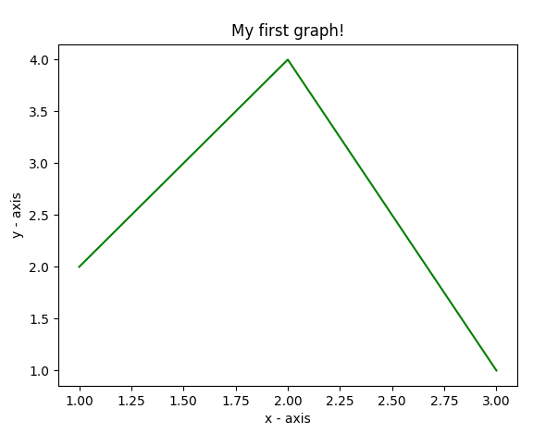

from matplotlib import pyplot as plt

x = [5,8,10]
#5 is sp of x axis 8 link with y axis and 10 is ep(reach) of x axis
y = [12,16,6]
#12 is sp of y axis 16 is with 8 peak point and 6 is sp of y axis no

plt.plot(x,y)

plt.title('Epic Info')
plt.ylabel('Y axis')
plt.xlabel('X axis')

plt.show()
Our new graph:
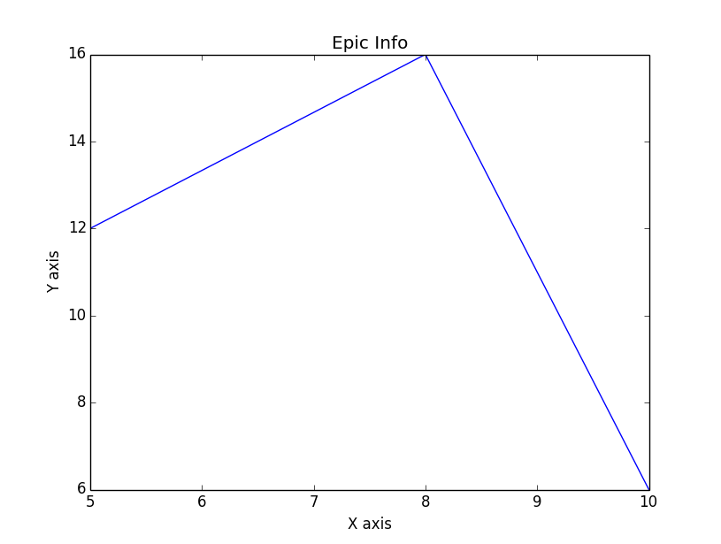
Customization of Plots
import matplotlib.pyplot as plt

# x axis values
x = [1,2,3,4,5,6]
# corresponding y axis values
y = [2,4,3,5,2,6]

# plotting the points
plt.plot(x, y, color='green', linestyle='dashed', linewidth = 3,
marker='o', markerfacecolor='blue', markersize=12)

# setting x and y axis range
plt.ylim(1,8)
plt.xlim(1,8)

# naming the x axis
plt.xlabel('x - axis')
# naming the y axis
plt.ylabel('y - axis')

# giving a title to my graph
plt.title('Some cool customizations!')

# function to show the plot
plt.show()

from matplotlib import pyplot as plt
from matplotlib import style

style.use('ggplot')

x = [5,8,10]
y = [12,16,6]

x2 = [6,9,11]
y2 = [6,15,7]

# can plot specifically, after just showing the defaults:
plt.plot(x,y,linewidth=5)
plt.plot(x2,y2,linewidth=5)

plt.title('Epic Info')
plt.ylabel('Y axis')
plt.xlabel('X axis')

plt.show()
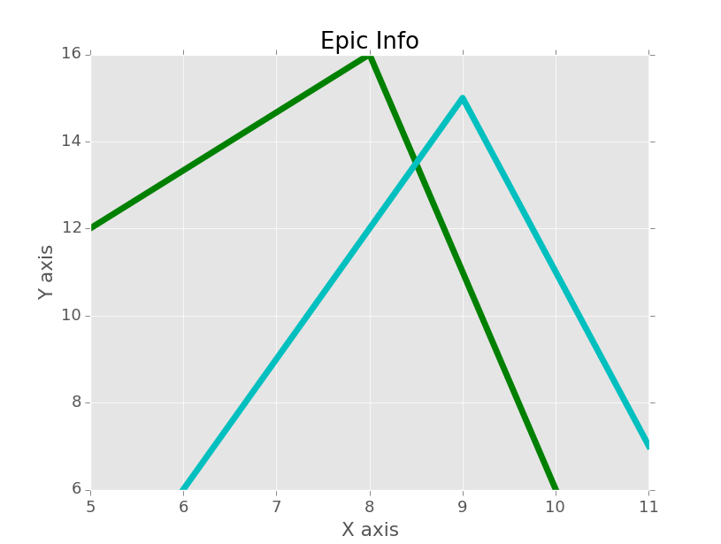

Bar Chart
Bar charts with matplotlib are basically 1 slight change, same with scatter plots. The only major change I like to make to bar charts is to center them, and that's about it:
import matplotlib.pyplot as plt
#Plotting to our canvas
x=["1","2","3"]
y=[2,4,5]
plt.barh(x,y)
for i,v in enumerate(y):
plt.text(v,i,str(v))

plt.show()

from matplotlib import pyplot as plt
from matplotlib import style

style.use('ggplot')

x = [5,8,10]
y = [12,16,6]

x2 = [6,9,11]
y2 = [6,15,7]

plt.bar(x, y, align='center')

plt.bar(x2, y2, color='g', align='center')

plt.title('Epic Info')
plt.ylabel('Y axis')
plt.xlabel('X axis')

plt.show()
Result:
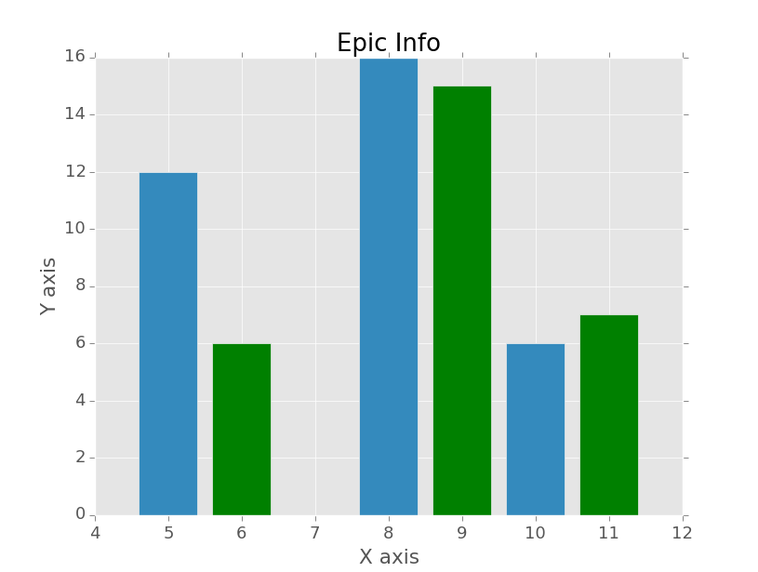
import matplotlib.pyplot as plt

# x-coordinates of left sides of bars
left = [1, 2, 3, 4, 5]

# heights of bars
height = [10, 24, 36, 40, 5]

# labels for bars
tick_label = ['one', 'two', 'three', 'four', 'five']

# plotting a bar chart
plt.bar(left, height, tick_label = tick_label,
width = 0.8, color = ['red', 'green'])

# naming the x-axis
plt.xlabel('x - axis')
# naming the y-axis
plt.ylabel('y - axis')
# plot title
plt.title('My bar chart!')

# function to show the plot
plt.show()
Output :
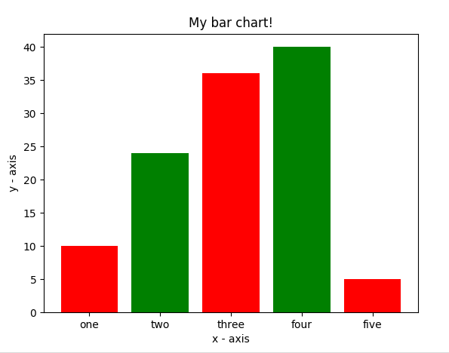
- Here, we use plt.bar() function to plot a bar chart.
- x-coordinates of left side of bars are passed along with heights of bars.
- you can also give some name to x-axis coordinates by defining tick_labels

Histogram
import matplotlib.pyplot as plt

# frequencies
ages = [2,5,70,40,30,45,50,45,43,40,44,
60,7,13,57,18,90,77,32,21,20,40]

# setting the ranges and no. of intervals
range = (0, 100)
bins = 10

# plotting a histogram
plt.hist(ages, bins, range, color = 'green',
histtype = 'bar', rwidth = 0.8)

# x-axis label
plt.xlabel('age')
# frequency label
plt.ylabel('No. of people')
# plot title
plt.title('My histogram')

# function to show the plot
plt.show()
Output:
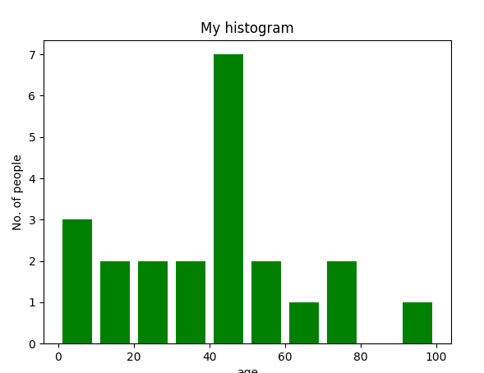
- Here, we use plt.hist() function to plot a histogram.
- frequencies are passed as the ages list.
- Range could be set by defining a tuple containing min and max value.
- Next step is to “bin” the range of values—that is, divide the entire range of values into a series of intervals—and then count how many values fall into each interval. Here we have defined bins = 10. So, there are a total of 100/10 = 10 intervals.

Scatter plot
import matplotlib.pyplot as plt

# x-axis values
x = [1,2,3,4,5,6,7,8,9,10]
# y-axis values
y = [2,4,5,7,6,8,9,11,12,12]

# plotting points as a scatter plot
plt.scatter(x, y, label= "stars", color= "green",
marker= "*", s=30)

# x-axis label
plt.xlabel('x - axis')
# frequency label
plt.ylabel('y - axis')
# plot title
plt.title('My scatter plot!')
# showing legend
plt.legend()

# function to show the plot
plt.show()
Output:
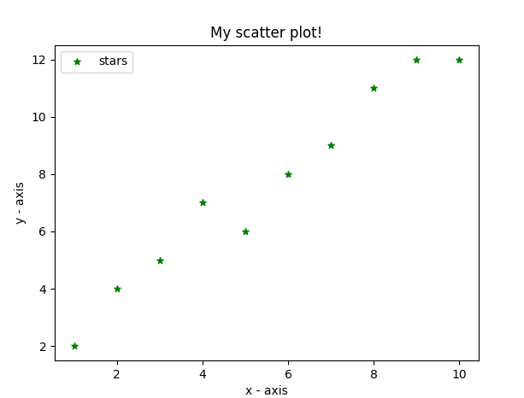
- Here, we use plt.scatter() function to plot a scatter plot.
- Like a line, we define x and corresponding y – axis values here as well.
- marker argument is used to set the character to use as marker. Its size can be defined using s parameter.

Pie-chart
import matplotlib.pyplot as plt

# defining labels
activities = ['eat', 'sleep', 'work', 'play']

# portion covered by each label
slices = [3, 7, 8, 6]

# color for each label
colors = ['r', 'y', 'g', 'b']

# plotting the pie chart
plt.pie(slices, labels = activities, colors=colors,
startangle=90, shadow = True, explode = (0, 0, 0.1, 0),
radius = 1.2, autopct = '%1.1f%%')

# plotting legend
plt.legend()

# showing the plot
plt.show()
Output of above program looks like this:
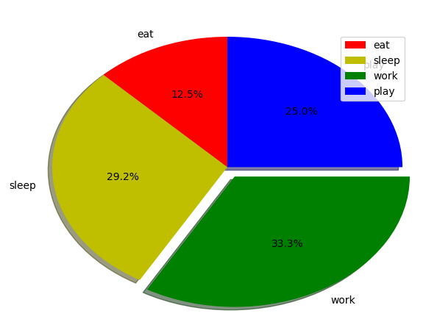
- Here, we plot a pie chart by using plt.pie() method.
- First of all, we define the labels using a list called activities.
- Then, portion of each label can be defined using another list called slices.
- Color for each label is defined using a list called colors.
- shadow = True will show a shadow beneath each label in pie-chart.
- startangle rotates the start of the pie chart by given degrees counterclockwise from the x-axis.
- explode is used to set the fraction of radius with which we offset each wedge.
- autopct is used to format the value of each label. Here, we have set it to show the percentage value only upto 1 decimal place.

Plotting curves of given equation
# importing the required modules
import numpy as np
import matplotlib.pyplot as plt
x = np.arange(0, 6, 1)
y = np.sin(x)
plt.plot(x, y)
plt.show()
Output of above program looks like this:
Here, we use NumPy which is a general-purpose array-processing package in python.
- To set the x – axis values, we use np.arange() method in which first two arguments are for range and third one for step-wise increment. The result is a numpy array.
- To get corresponding y-axis values, we simply use predefined np.sin() method on the numpy array.
- Finally, we plot the points by passing x and y arrays to the plt.plot() function.
So, in this part, we discussed various types of plots we can create in matplotlib. There are more plots which haven’t been covered but the most significant ones are discussed here –

This code import Excel File
Working on Excel File
import pandas as pd
f =r'D:\Book2.xlsx'
r = pd.read_excel(f)
r.head()
or
print(r)
import pandas as pd
data = pd.read_excel (r'D:\Book2.xlsx')
df = pd.DataFrame(data, columns= ['Name','Age'])
print (df)

To display column heading with selected sheet
import pandas as pd
df = pd.read_excel(r'D:\Book2.xlsx', sheet_name='Sheet1')
print("Column headings:")
print(df.columns)
print(df['Name'])
n = df['Name']
a = df['Age']
print(n,a)

Open Excel Sheet From Dialogue Box
import tkinter as tk
from tkinter import filedialog
import pandas as pd

root= tk.Tk()

canvas1 = tk.Canvas(root, width = 600, height = 300, bg = 'Gray')
canvas1.pack()

def getExcel ():
# global df
fp = filedialog.askopenfilename()
df = pd.read_excel (fp)
print (df)

btn = tk.Button(text='Browse Excel File', command=getExcel, bg='blue', fg='white', font=('helvetica', 12, 'bold'))
canvas1.create_window(300, 150, window=btn)

root.mainloop()

XlsxWriter is a Python library using which one can perform multiple operations on excel files like creating, writing, arithmetic operations and plotting graphs. Let’s see how to plot Combined charts using realtime data.
Charts are composed of at least one series of one or more data points. Series themselves are comprised of references to cell ranges. For plotting the charts on an excel sheet, firstly, create chart object of specific chart type( i.e Line, Column chart etc.). After creating chart objects, insert data in it and lastly, add that chart object in the sheet object.
Following code create Sheet3 and write data on this sheet

Write Data on Excel File by XlsxWriter
import pandas as pd

# Create a Pandas dataframe from some data.
df = pd.DataFrame({'Data': ['Saturday', 'Sunday', 'Monday', 'Tuesday',
'Wednesday', 'Thrusday', 'Friday']})

# Create a Pandas Excel writer
# object using XlsxWriter as the engine.
writer = pd.ExcelWriter(r'D:\Book2.xlsx', engine ='xlsxwriter')

# Write a dataframe to the worksheet.
df.to_excel(writer, sheet_name ='Sheet3')

# Close the Pandas Excel writer
# object and output the Excel file.
writer.save()

openpyxl is a Python library using which one can perform multiple operations on excel files like reading, writing, arithmatic operations and plotting graphs. Let’s see how to perform different arithmatic operations using openpyxl.
=SUM(cell1:cell2) : Adds all the numbers in a range of cells.

# import openpyxl module
import openpyxl

# Call a Workbook() function of openpyxl
# to create a new blank Workbook object
wb = openpyxl.Workbook()

# Get workbook active sheet
# from the active attribute.
sheet = wb.active

# writing to the cell of an excel sheet
sheet['A1'] = 200
sheet['A2'] = 300
sheet['A3'] = 400
sheet['A4'] = 500
sheet['A5'] = 600

# The value in cell A7 is set to a formula
# that sums the values in A1, A2, A3, A4, A5 .
sheet['A7'] = '= SUM(A1:A5)'

# save the file
wb.save(r"D:\sum.xlsx")
=PRODUCT(cell1:cell2) : Multiplies all the numbers in the range of cells.

import openpyxl

wb = openpyxl.Workbook()
sheet = wb.active

sheet['A1'] = 2
sheet['A2'] = 3
sheet['A3'] = 4
sheet['A4'] = 5
sheet['A5'] = 6

# The value in cell A7 is set to a formula
# that multiplies the values in A1, A2, A3, A4, A5 .
sheet['A7'] = '= PRODUCT(A1:A5)'

wb.save("product.xlsx")

=AVERAGE(cell1:cell2) : It gives the average (arithmetical mean) of all the numbers which is present in the given cell range.
import openpyxl

wb = openpyxl.Workbook()
sheet = wb.active

sheet['A1'] = 200
sheet['A2'] = 300
sheet['A3'] = 400
sheet['A4'] = 500
sheet['A5'] = 600

# The value in cell A7 is set to a formula
# that return average of the values in A1, A2, A3, A4, A5 .
sheet['A7'] = '= AVERAGE(A1:A5)'

wb.save("average.xlsx")

=MOD(num1, num2) : Returns the remainder after a number is divided by the divisor.
import openpyxl

wb = openpyxl.Workbook()
sheet = wb.active

# The value in cell is set to a formula
# that gives remainder or modulus value.
sheet['A1'] = '= MOD(64, 8)'
sheet['A2'] = '= MOD(25, 4)'

wb.save("modulus.xlsx")

=COUNT(cell1:cell2) : It counts the number of cells in a range that contain the number.
import openpyxl

wb = openpyxl.Workbook()
sheet = wb.active

sheet['A1'] = 200
sheet['A2'] = 300
sheet['A3'] = 400
sheet['A4'] = 500
sheet['A5'] = 600

# The value in cell A7 is set to a formula
# that gives counting of number present in the cells.
sheet['A7'] = '= COUNT(A1:A6)'

wb.save("count.xlsx")

Plot the Bar Chart
For plotting the bar chart on an excel sheet, use BarChart class from openpyxl.chart submodule.

import openpyxl

# import BarChart class from openpyxl.chart sub_module
from openpyxl.chart import BarChart,Reference

# Call a Workbook() function of openpyxl
# to create a new blank Workbook object
wb = openpyxl.Workbook()

# Get workbook active sheet
# from the active attribute.
sheet = wb.active

# write o to 9 in 1st column of the active sheet
for i in range(10):
sheet.append([i])

# create data for plotting
values = Reference(sheet, min_col = 1, min_row = 1,
max_col = 1, max_row = 10)

# Create object of BarChart class
chart = BarChart()

# adding data to the Bar chart object
chart.add_data(values)

# set the title of the chart
chart.title = " BAR-CHART "

# set the title of the x-axis
chart.x_axis.title = " X_AXIS "

# set the title of the y-axis
chart.y_axis.title = " Y_AXIS "

# add chart to the sheet
# the top-left corner of a chart
# is anchored to cell E2 .
sheet.add_chart(chart, "E2")

# save the file
wb.save("barChart.xlsx")

Plot the 3D Bar Chart
For plotting the 3D bar chart on an excel sheet, use BarChart3D class from openpyxl.chart submodule.

import openpyxl

# import BarChart3D class from openpyxl.chart sub_module
from openpyxl.chart import BarChart3D,Reference

# write o to 9 in 1st column of the active sheet
for i in range(10):
sheet.append([i])

values = Reference(sheet, min_col = 1, min_row = 1,
max_col = 1, max_row = 10)

# Create object of BarChart3D class
chart = BarChart3D()

chart.add_data(values)

# set the title of the chart
chart.title = " BAR-CHART3D "

# set the title of the x-axis
chart.x_axis.title = " X AXIS "

# set the title of the y-axis
chart.y_axis.title = " Y AXIS "

# add chart to the sheet
# the top-left corner of a chart
# is anchored to cell E2.
sheet.add_chart(chart, "E2")

# save the file
wb.save("BarChart3D.xlsx")

Code #3 : Plot the Area Chart
For plotting the Area chart on an excel sheet, use AreaChart class from openpyxl.chart submodule.

import openpyxl

# import AreaChart class from openpyxl.chart sub_module
from openpyxl.chart import AreaChart,Reference

wb = openpyxl.Workbook()
sheet = wb.active

# write o to 9 in 1st column of the active sheet
for i in range(10):
sheet.append([i])

values = Reference(sheet, min_col = 1, min_row = 1,
max_col = 1, max_row = 10)

# create object of AreaChart class
chart = AreaChart()

chart.add_data(values)

# set the title of the chart
chart.title = " AREA-CHART "

# set the title of the x-axis
chart.x_axis.title = " X-AXIS "

# set the title of the y-axis
chart.y_axis.title = " Y-AXIS "

# add chart to the sheet
# the top-left corner of a chart
# is anchored to cell E2 .
sheet.add_chart(chart, "E2")

# save the file
wb.save("AreaChart.xlsx")

Plot the 3D Area Chart
For plotting the 3D Area chart on an excel sheet, use AreaChart3D class from openpyxl.chart submodule.

import openpyxl

# import AreaChart3D class from openpyxl.chart sub_module
from openpyxl.chart import AreaChart3D,Reference

wb = openpyxl.Workbook()
sheet = wb.active

# write o to 9 in 1st column of the active sheet
for i in range(10):
sheet.append([i])

values = Reference(sheet, min_col = 1, min_row = 1,
max_col = 1, max_row = 10)

# Create object of AreaChart3D class
chart = AreaChart3D()

chart.add_data(values)

# set the title of the chart
chart.title = " AREA-CHART3D "

# set the title of the x-axis
chart.x_axis.title = " X-AXIS "

# set the title of the y-axis
chart.y_axis.title = " Y-AXIS "

# add chart to the sheet
# the top-left corner of a chart
# is anchored to cell E2 .
sheet.add_chart(chart, "E2")

# save the file
wb.save("AreaChart3D.xlsx")

Plot a Line Chart.
For plotting the Line chart on an excel sheet, use LineChart class from openpyxl.chart submodule.
# import openpyxl module
import openpyxl

# import LineChart class from openpyxl.chart sub_module
from openpyxl.chart import LineChart,Reference

wb = openpyxl.Workbook()
sheet = wb.active

# write o to 9 in 1st column of the active sheet
for i in range(10):
sheet.append([i])

values = Reference(sheet, min_col = 1, min_row = 1,
max_col = 1, max_row = 10)

# Create object of LineChart class
chart = LineChart()

chart.add_data(values)

# set the title of the chart
chart.title = " LINE-CHART "

# set the title of the x-axis
chart.x_axis.title = " X-AXIS "

# set the title of the y-axis
chart.y_axis.title = " Y-AXIS "

# add chart to the sheet
# the top-left corner of a chart
# is anchored to cell E2 .
sheet.add_chart(chart, "E2")

# save the file
wb.save("LineChart.xlsx")

Plot a 3D Line Chart.
For plotting the 3D Line chart on an excel sheet we have to use LineChart3D class from openpyxl.chart submodule.
import openpyxl

# import LineChart3D class from openpyxl.chart sub_module
from openpyxl.chart import LineChart3D,Reference

wb = openpyxl.Workbook()
sheet = wb.active

# write o to 9 in 1st column of the active sheet
for i in range(10):
sheet.append([i])

values = Reference(sheet, min_col = 1, min_row = 1,
max_col = 1, max_row = 10)

# Create object of LineChart3D class
chart = LineChart3D()

chart.add_data(values)

# set the title of the chart
chart.title = " LINE-CHART3D "

# set the title of the x-axis
chart.x_axis.title = " X-AXIS "

# set the title of the y-axis
chart.y_axis.title = " Y-AXIS "

# add chart to the sheet
# the top-left corner of a chart
# is anchored to cell E2 .
sheet.add_chart(chart, "E2")

# save the file
wb.save("LineChart3D.xlsx")

